SARIMA-PSO-TCN-Based Short-Term Forecasting of Electric Vehicle Charging Station Load Demand
Leister James M. Javier
Electrical Engineering Department
University of Santo Tomas
Manila, Philippines
0009-0000-4254-3714

Carlos Louis P. Pineda
Electrical Engineering Department
University of Santo Tomas
Manila, Philippines
0009-0000-9986-9977
Ivan Nickol D. Marantan
Electrical Engineering Department
University of Santo Tomas
Manila, Philippines
0009-0002-9887-4242

Ariane Joyce V. Gara
Electrical Engineering Department
University of Santo Tomas
Manila, Philippines
0009-0001-4679-4315

Justine B. Matias
Electrical Engineering Department
University of Santo Tomas
Manila, Philippines
0009-0002-3386-2283

Abstract—In this work, a residual learning framework was introduced for short-term forecasting of the electric vehicle charging-station load demand. The framework used a City novel short-term forecasting framework to predict EV charging demand, combining Boulder historical charging records from January 2018 to November 2023 after cleaning and standardizing the records, and then splitting the aggregated historical demand into training, validation, and test sets. Historical demand was aggregated to form the charging-station hourly energy demand using min–max scaling, and the records are sorted in chronological order. For the short-term forecasting of the demand, the framework utilized a combination of a Seasonal Autoregressive Integrated Moving Average (SARIMA) model and a Temporal Convolutional Network (TCN), where the hyperparameters of the residual learner were tuned utilizing two optimization techniques, namely Genetic Algorithm (GA) and Particle Swarm Optimization (PSO), in which six competing models were developed, namely SARIMA-GA-TCN, SARIMA-PSO-TCN, GA-TCN, PSO-TCN, SARIMA, and TCN. These models were compared using MAE, RMSE, SMAPE, R², and the HLN-corrected Diebold-Mariano test. SARIMA-PSO-TCN achieved the strongest aligned test performance with MAE = 9.1111 kWh, RMSE = 12.7573 kWh, SMAPE = 29.7414%, and R² = 0.8805. The hyperparameter tuning process significantly improved the performance of short-term EV charging demand forecasting.
Index Terms—electric vehicle charging, load forecasting, SARIMA, temporal convolutional network, genetic algorithm, particle swarm optimization, time-series forecasting.
I. INTRODUCTION
Short-term load forecasting is a key requirement for reliable power-system operation because inaccurate demand estimates can increase operating cost and reduce reliability [1]. The task becomes more difficult as electrification introduces variable loads. At the charging-station level, EV demand is not a smooth household-load signal; it is produced by irregular charging sessions affected by arrival time, charging duration, station availability, remaining battery level, and time-of-day behavior [2]-[7].
A related IEEE conference paper presents an in-depth investigation of the impact of Electric Vehicles (EVs) charging on load profiles. In the paper, the authors arrive at the conclusion that in order to accurately forecast the EV charging demand using conventional time and weather features, the charging behavior has to be embedded into these features. The present work focused on deterministic station-level EV charging demand using historical public charging-station records.
The main contribution was a compact SARIMA-TCN residual framework optimized by GA and PSO. SARIMA extracted the recurring seasonal structure from hourly charging demand, and TCN learned the residual nonlinear component. The final forecast was obtained by adding the SARIMA output and the optimized residual prediction. The framework was evaluated against SARIMA, TCN, GA-TCN, and PSO-TCN baselines using aligned test observations and HLN-corrected Diebold-Mariano (HLN-DM) testing.
II. RELATED WORK AND RESEARCH GAP
EV charging forecasting studies have used statistical models, neural networks, probabilistic methods, and spatio-temporal learning. Probabilistic feeder-level models have been investigated for EV charging forecasting. Studies on forecasting charging of EVs, including charging-related features, and forecasting demand for charging of EVs at the station level [2]-[7]. The studies mentioned above have shown that the demand for charging EVs depends on temporal patterns in the data, user behavior, and the operating context.
SARIMA models have been shown to capture and produce accurate medium-term forecasts for time series with a single main seasonal pattern, i.e., those that recur daily. Furthermore, such models can decompose a time series into Trend, Seasonal, and Residual (or Irregular) components. However, it has been well documented that such models can oversmooth sudden peaks in demand and are unable to model nonlinear behavior in the residuals. Conversely, Temporal Convolutional Networks (TCNs) have been well-suited to sequential forecasting problems, because the input data of a time-series follows a temporal order, which the use of causal convolution within a TCN preserves. Additionally, dilated convolution within a TCN increases the network's receptive field without the need for recursive feedback.
Using a metaheuristic search to find the optimal hyperparameters of a time-series model, rather than a manual search, greatly reduces search time. In a Genetic Algorithm (GA) search, the space of possible hyperparameter combinations is explored using selection, crossover, and mutation [12], [13]. In a Particle Swarm Optimization (PSO) search, a set of possible hyperparameter combinations is updated using the inertia and the best solutions found so far (personal best and global best) [14], [20]. This work addressed the research gap that exists between 1) seasonal statistical decomposition, 2) optimizer-assisted TCN residual learning, and 3) formal statistical significance testing for short-term forecasting of station-level EV charging demand.
III. DATASET AND METHODOLOGY
A. Dataset and preprocessing
The City of Boulder EV charging station dataset from January 2018 to November 2023 was used as the reference dataset for the current study. Raw charging sessions and records were cleaned by removing duplicate or invalid data entries, standardizing timestamps, and aggregating charging energy into hourly demand sequences. The hourly-aggregated data were normalized and split chronologically into 80% training, 10% validation, and 10% test sets. This split configuration preserved the temporal order of the dataset while preventing future observations from leaking into the model during training.
TABLE I. STUDY DESIGN AND DATA PREPARATION SUMMARY
Item | Description
Dataset | City of Boulder EV charging-station records, January 2018 to November 2023
Preprocessing | Cleaning, timestamp standardization, hourly kWh aggregation, feature preparation, and min-max normalization
Split | 80% training, 10% validation, and 10% testing using chronological order
Models | SARIMA, TCN, GA-TCN, PSO-TCN, SARIMA-GA-TCN, and SARIMA-PSO-TCN
Metrics | MAE, RMSE, SMAPE, R², and HLN-corrected Diebold-Mariano test
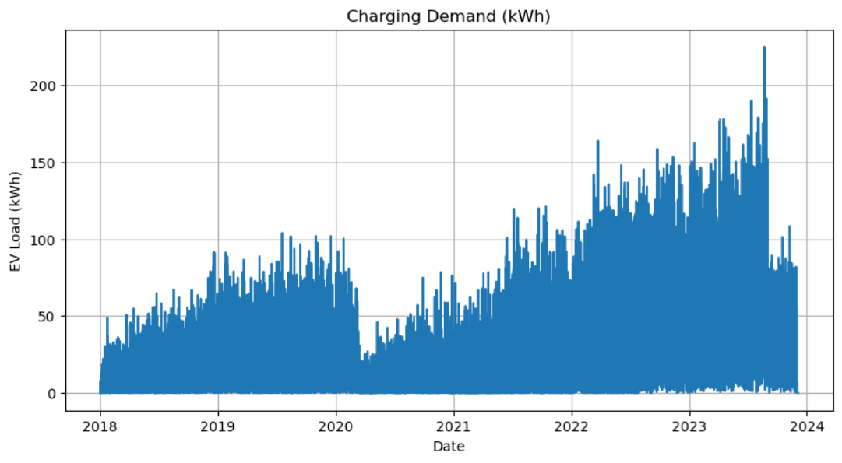
Fig. 1. Cleaned and aggregated hourly EV charging demand series.
The one-week diagnostic view used in the results corresponds to the first 168 hourly test observations. The evaluation was performed on hourly observations, and seven days contain 168 hourly points.
B. Hybrid SARIMA-TCN forecasting framework
The SARIMA model for the hourly charging sequence was fitted to forecast the seasonal-linear component of the demand. The residual between this forecasted demand and the actual charging demand was then used as input to the TCN residual learner. This was able to model short- and long-range residual dependencies using causal and dilated convolutions. Hyperparameters for the TCN learner, such as the number of filters, kernel size, learning rate, and training batch size, were defined for the GA and PSO search spaces. A retained summary reported the final architecture and the corresponding learning-rate settings in detail.
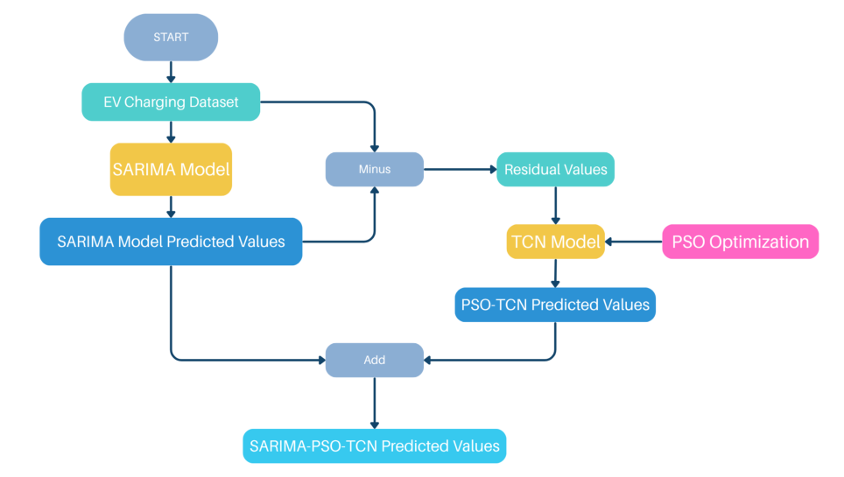
Fig. 2. SARIMA-PSO-TCN residual hybrid forecasting framework.
TABLE II. FORECASTING COMPONENTS AND MODEL ROLES
Component | Role in the forecasting framework
SARIMA | Models the linear and recurring seasonal backbone of hourly EV charging demand.
TCN | Learns nonlinear temporal dependencies from the SARIMA residual sequence.
GA | Searches candidate TCN settings through selection, crossover, and mutation.
PSO | Searches candidate TCN settings using velocity, personal best, and global best updates.
Hybrid output | Adds the SARIMA forecast and optimized TCN residual correction.
C. Key mathematical formulation
Only the key formulas are retained for the conference version. The hourly demand values were normalized before model training as
$x_{i}^{*}=\frac{x_{i} - x_{min}}{x_{max}-x_{min}}$ | (1)
SARIMA represented the seasonal-linear portion of the series:
$ϕ_{p}(B)Φ_{p}(B^{s})(1-B)^{d}{(1-B^{s})^{D}X}_{t}=θ_{q}(B){Θ_{Q}(B^{s})ω}_{t}$ | (2)
The residual and final hybrid forecast were computed as
$r(t) = y(t)-{\hat{y}}_{SARIMA}(t)$ | (3)
${\hat{y}}_{final(t)}={\hat{y}}_{SARIMA(t) }+ {\hat{r}}_{TCN(t)}$ | (4)
The TCN residual learner used dilated convolution to model the residual sequence:
$y(t) = \sum_{i=0}^{k-1}{}w(i)⋅x(t-d'⋅i)$ | (5)
PSO updated the candidate TCN hyperparameters by
$v_{i}^{t+1}=wv_{i}^{t}+c_{1}{r_{1}(pbest_{i}-}_{}x_{i}^{t})+c_{2}{r_{2}(gbest-}_{}x_{i}^{t})$ | (6)
The performance matrices used were MAE, RMSE, SMAPE, and R². Statistical significance of the results was evaluated using the HLN-corrected Diebold–Mariano test utilizing squared error loss. For each model m, the forecast error and squared loss were:
$e_{m,t}=y_{t}-{\hat{y}}_{m,t}$ | $L_{m,t}=(e_{m,t})^{2}$ | (7)
The loss differential, mean loss differential, and DM statistic were computed as
$d_{t}=L_{1,t}-L_{2,t}$ | $\underline{d}=\frac{1}{n}\sum_{t=1}^{n}{}d_{t}$, | $DM=\frac{\underline{d}}{SE}$ | (8)
The HLN-corrected statistic was then obtained using
$C_{HLN}=\sqrt{\frac{n+1-2h+\frac{h(h-1)}{n}}{n}}$ | $HLN-DM=DM×C_{HLN}$ | (9)
Since the forecasts were evaluated using matched hourly observations, the comparison horizon was set to h=1. Squared error loss was used to penalize large deviations more strongly during model analysis and comparison.

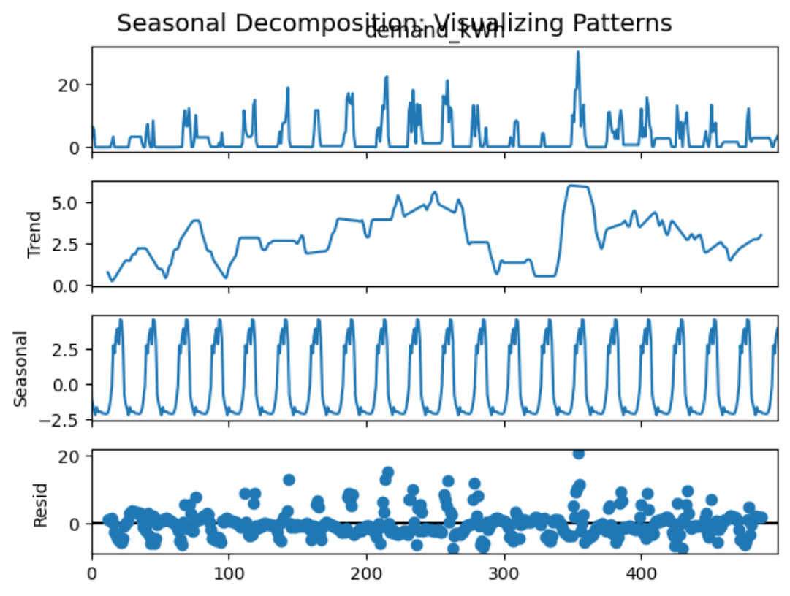
Fig. 3. Seasonal decomposition of the EV charging demand series.
The decomposition plot showed the separated components of the EV charging demand time series. The seasonal component contained daily repetition in the data, while the residuals showed irregular deviations that are better modeled by a nonlinear residual model. Thus, instead of forcing one model to learn all components, the research first used SARIMA as the seasonal backbone, and then used a TCN as a correction model for the remaining nonlinear residual patterns.
D. Benchmarking protocol
For the benchmarking, six models were evaluated: SARIMA, TCN, GA-TCN, PSO-TCN, SARIMA-GA-TCN, and SARIMA-PSO-TCN. The comparison was done based on the performance metrics and aligned by timestamp to accommodate the statistical significance analysis testing.
IV. RESULTS AND DISCUSSION
The hourly demand series contained recurring daily behavior and irregular peaks, supporting the residual hybrid design. SARIMA captured the stable seasonal backbone, while the optimized TCN learned the residual nonlinear variation that remained after the statistical forecast.
TABLE III. MODEL PERFORMANCE COMPARISON
Model | MAE | RMSE | SMAPE | R²
SARIMA | 17.6762 | 23.9014 | 47.3792 | 0.5800
TCN | 11.3919 | 16.9540 | 33.0325 | 0.7887
GA-TCN | 10.1580 | 15.0918 | 30.6087 | 0.8326
PSO-TCN | 9.9643 | 14.9767 | 26.4656 | 0.8351
SARIMA-GA-TCN | 9.5573 | 13.1999 | 30.7223 | 0.8721
SARIMA-PSO-TCN | 9.1111 | 12.7573 | 29.7414 | 0.8805
Table III showed that SARIMA-PSO-TCN achieved the lowest errors and the best fit. The best model, in terms of error and fit, was the SARIMA-PSO-TCN hybrid model. This model performed better than the SARIMA-GA-TCN model across MAE, RMSE, SMAPE, and R². Although the improvements are relatively small, the better model is the SARIMA-PSO-TCN model with MAE, RMSE, SMAPE, and R² values of 9.1111, 12.7573, 29.7414, and 0.8805, respectively, compared with MAE, RMSE, SMAPE, and R² values of 9.5573, 13.1999, 30.7223, and 0.8721 for the SARIMA-GA-TCN model.

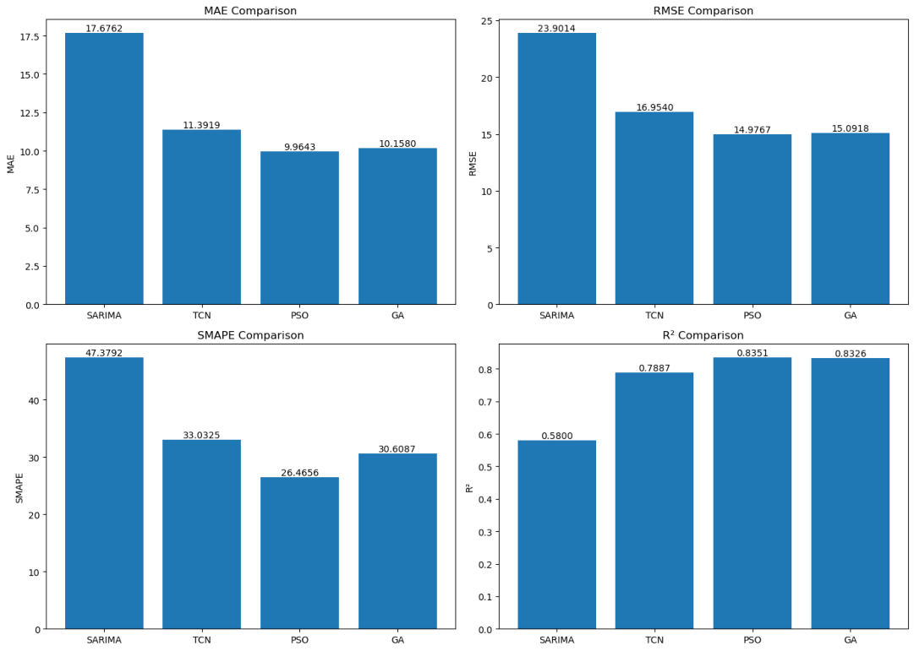
Fig. 4. Baseline and optimizer-only model comparison across MAE, RMSE, SMAPE, and R².
Fig. 4 shows the increase in performance before the hybrid models in Table III are introduced. SARIMA had the largest errors, but these were dramatically reduced by the addition of optimizers, as shown in the figure for the models GA-TCN and PSO-TCN.
TABLE IV. RETAINED TCN RESIDUAL-LEARNER SETTINGS
Optimizer | Filters | Kernel size | Learning rate
GA | 104 | 2 | 0.123789
PSO | 65 | 5 | 0.118498
Table IV presents the parameters of the TCN that were retained in the end for the residual learners of the SARIMA-GA-TCN and SARIMA-PSO-TCN models. These parameters are the final settings for learning the nonlinear residuals.
TABLE V. SELECTED HLN-DM TEST RESULTS
Comparison | HLN-DM | p-value | Better model
SARIMA vs TCN | 29.8527 | 6.33E-188 | TCN
TCN vs GA-TCN | 34.1516 | 2.49E-242 | GA-TCN
TCN vs PSO-TCN | 35.6240 | 2.61E-262 | PSO-TCN
GA-TCN vs SARIMA-GA-TCN | 13.0607 | 1.12E-38 | SARIMA-GA-TCN
PSO-TCN vs SARIMA-PSO-TCN | 17.5222 | 9.16E-68 | SARIMA-PSO-TCN
All selected HLN-DM comparisons were significant at the 5% level. The table reported the stepwise statistical comparisons used to verify improvements from the baseline models to the optimized and hybrid models. Since the summarized table does not include every possible pairwise test, SARIMA-PSO-TCN was interpreted as the strongest model based on its reported metric performance and statistically supported stepwise comparisons.
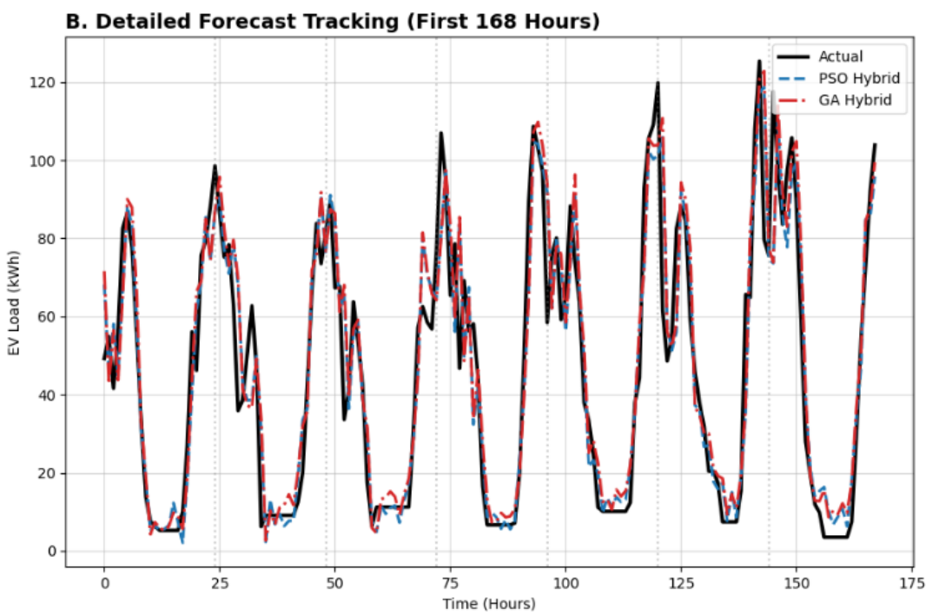
Fig. 5. One-week hybrid forecast tracking for the first 168 hourly test observations.
Figure 5 illustrates the initial performance of both hybrid models over a one-week evaluation period. Notably, the trajectories for both models closely aligned with the recurring daily demand patterns of the reference series across the majority of the temporal horizon. The remaining deviations are marginal and primarily characterized by phase shifts in peak timing—wherein localized disparities emerge between high- and low-demand intervals across different time steps—as well as minor calibration errors during periods of comparable peak demand magnitude.
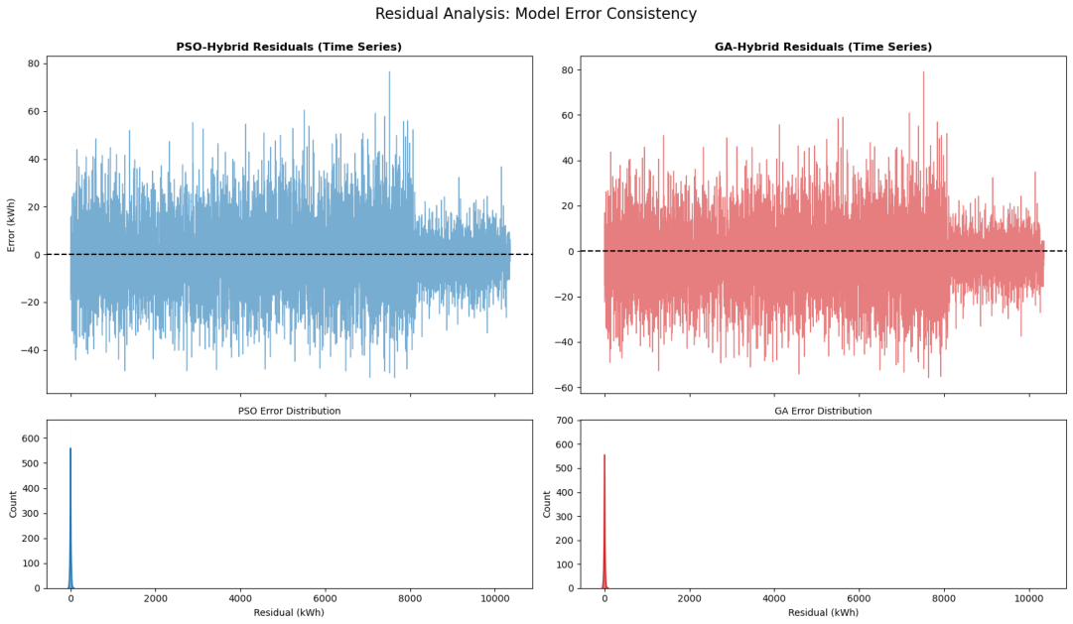
Fig. 6. Residual volatility and error consistency of the two hybrid models.
As depicted in the residual distributions, both hybrids remained near zero for most of the test interval but exhibited high variance. Consequently, these distributions must be analyzed in conjunction with the previously detailed numerical error metrics to determine the optimal model for a given application.
The experimental results indicated that the PSO-tuned hybrid performs best. The PSO search successfully identified a good residual-learner configuration, which is a trade-off between the receptive field of the residual-learner and the compactness of the learner itself. This result is valid only for the current test dataset, the selected preprocessing pipeline, and the baseline GA comparison.
The resulting forecast closely tracked the primary daily demand trends across most days, with the remaining errors heavily concentrated around sharp peaks and troughs. Therefore, including external information such as occupancy, price, traffic, and weather may furthe r improve peak and off-peak demand forecasts.
In contrast to probabilistic electric vehicle load forecasting, this study focused on the deterministic, station-level forecasting problem. EV charging inherently increases grid demand uncertainty. Consequently, while predicting expected demand is essential for infrastructure dimensioning, identifying scenarios prone to high forecast errors is equally critical. Within the scope of this conference paper, the derivation of prediction intervals is reserved for future work.
Furthermore, model performance may degrade when charging behavior is affected by the installation of new charging facilities, by users adjusting their charging patterns, or by local policy changes that affect demand. A practical implementation of the model described in this paper must therefore monitor error over time and retrain the residual learner when necessary.
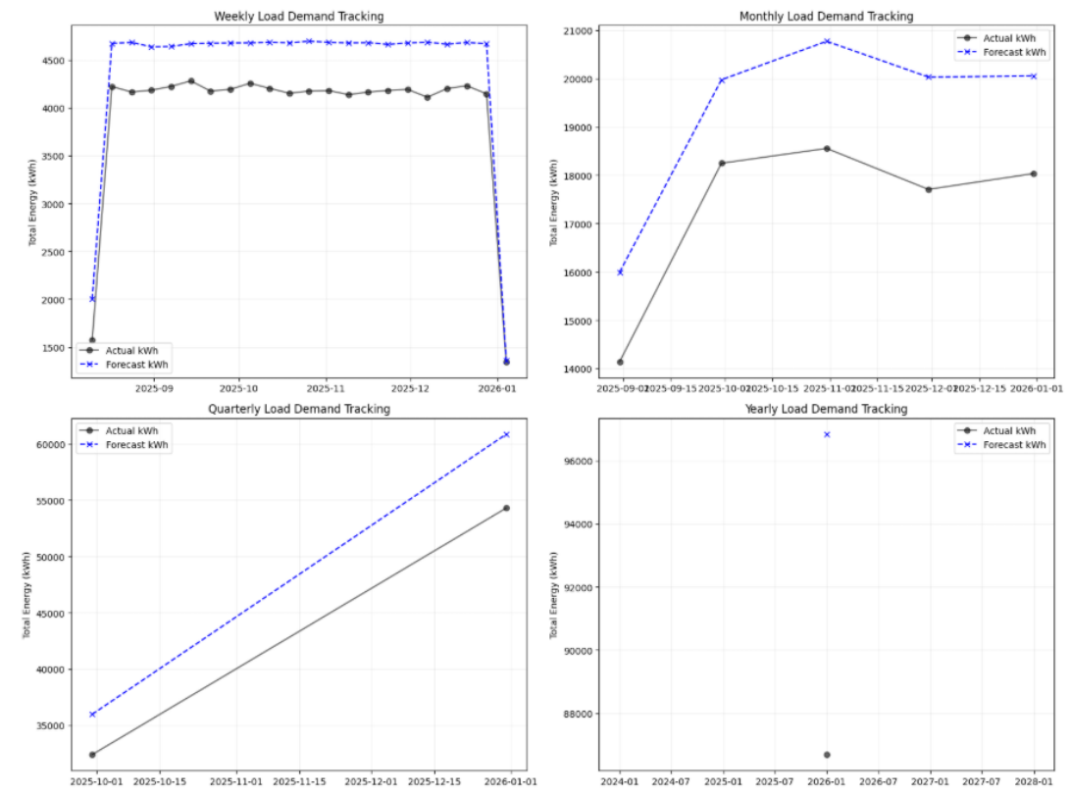
Fig. 7. Aggregated final prediction views showing calibration behavior.
Fig. 7 illustrates why forecast evaluation should not stop at a single metric table. Although the hourly aligned test metrics favor SARIMA-PSO-TCN, aggregated views can reveal systematic overestimation or underestimation that may be hidden when results are summarized only by MAE or RMSE. This is relevant for operational use because station operators may use weekly or monthly summaries for scheduling, procurement, or maintenance decisions.
The aggregated diagnosis suggested two future improvements. First, post-processing calibration can shift or scale forecasts when persistent bias is detected. Second, exogenous features can be added to explain changes not captured by the historical load alone. Weather, pricing, occupancy, public events, charger availability, and traffic conditions are potential variables that may reduce residual volatility and improve transferability to other charging networks.
The work is aligned with intelligent and sustainable energy-system themes because it combines statistical modeling, deep sequence learning, and swarm/evolutionary optimization to support more reliable EV infrastructure operation. The approach can be adapted to other public charging datasets by retaining the same preprocessing, residual learning, and aligned evaluation pipeline.
V. IMPLICATIONS, LIMITATIONS, AND CONCLUSION
The results indicated that the hybrid model was useful for short-term forecasting of EV charging station loads. SARIMA captured recurring seasonal structure, while the optimized TCN provided the nonlinear correction. The proposed framework performed better than the benchmarking models used for the dataset and the preprocessing method.
For EV charging providers, the forecast could support the anticipation, scheduling, and maintenance of charging congestion. For electric utilities, station-focused forecasting could serve as a basis for feeder-level load analysis and planning, especially as EV demand becomes less predictable.
This work was limited by the use of only the City of Boulder dataset, the selected preprocessing steps, the chosen model configurations, and the single aligned test period. The results could improve with added weather, station occupancy, traffic, pricing, and special-event variables. The final prediction results should also be interpreted carefully because aggregated views indicated possible overestimation.
Future work may extend the framework to probabilistic forecasting and prediction-interval evaluation so operators can assess both expected demand and forecast uncertainty.
Overall, SARIMA-PSO-TCN produced the most accurate forecast, but the result remains dataset-specific. Its broader contribution is the residual hybrid procedure supported by aligned metrics and statistical testing.
A. Practical implementation notes
For implementation, the forecasting process should be set up as a workflow that can be run frequently, rather than running a single model once. First, the charging-session records need to be cleaned, with the timestamps standardized where necessary. Then, the data is transformed into hourly charging demand. The same preprocessing steps that were used for the training data should also be applied to data from new or previously unseen charging stations as they arrive. This ensured that incoming data followed the same scale as the training data.
The SARIMA component should be reviewed or refitted when the demand pattern shows changes in seasonality. The TCN residual learner should also be retrained when validation errors start to increase or become unstable. In an actual deployment, this review can be done monthly or whenever a station is added, removed, or affected by a new operating policy. The GA or PSO tuning process does not need to be performed daily; it should be repeated only when the residual learner no longer produces consistent forecasting results.
B. Final conclusion
For the test period, the best nonlinear correction was provided by the PSO-tuned residual learner in the SARIMA-PSO-TCN model.
Although the results obtained by the proposed method are strong, the method should be used as a forecasting aid for grid demand rather than as a complete grid-operation program. The model does not account for voltage effects in the distribution network, transformer or transformer-bank loading, harmonics, or other power-quality issues. To support grid planning, the demand forecasts produced by the proposed method should be used together with a distribution-system simulation model or a hosting-capacity analysis. The forecast may also be integrated with EV charging-scheduling strategies. With such integration, the predicted demand can be evaluated in terms of its actual effects on grid operation and infrastructure loading.
Future work should also compare deterministic and probabilistic forecasting. A future version of the present framework may therefore produce both point forecasts and prediction intervals, enabling charging providers and utilities to prepare not only for the expected demand but also for plausible upper and lower demand scenarios.
REFERENCES
[1] N. Shi, F. Zhang, Z. Wang, J. S. MacDonald, M. Baudette, Y. Lin, and V. Motakatla, “Short-term load forecasting considering EV charging loads with prediction interval evaluation,” in Proc. 56th North American Power Symp. (NAPS), 2024, doi: 10.1109/NAPS61145.2024.10741734.
[2] A. Orzechowski et al., “A data-driven framework for medium-term electric vehicle charging demand forecasting,” Energy and AI, vol. 14, Art. no. 100267, 2023.
[3] J. Tian, H. Liu, W. Gan, Y. Zhou, N. Wang, and S. Ma, “Short-term electric vehicle charging load forecasting based on TCN-LSTM network with comprehensive similar day identification,” Applied Energy, vol. 381, Art. no. 125174, 2025.
[4] S. Wang, A. Chen, P. Wang, and C. Zhuge, “Predicting electric vehicle charging demand using a heterogeneous spatio-temporal graph convolutional network,” Transp. Res. Part C, vol. 153, Art. no. 104205, 2023.
[5] T. Cao, Y. Xu, G. Liu, S. Tao, W. Tang, and H. Sun, “Feature-enhanced deep learning method for electric vehicle charging demand probabilistic forecasting of charging station,” Applied Energy, vol. 371, Art. no. 123751, 2024.
[6] M. A. Zamee, D. Han, H. Cha, and D. Won, “Self-supervised online learning algorithm for electric vehicle charging station demand and event prediction,” J. Energy Storage, vol. 71, Art. no. 108189, 2023.
[7] X. Ge, L. Shi, Y. Fu, S. M. Muyeen, Z. Zhang, and H. He, “Data-driven spatial-temporal prediction of electric vehicle load profile considering charging behavior,” Electric Power Systems Research, vol. 187, Art. no. 106469, 2020.
[8] M. Farsi et al., “Parallel genetic algorithms for optimizing the SARIMA model for better forecasting of the NCDC weather data,” Alexandria Eng. J., vol. 60, no. 1, pp. 1299-1316, 2020.
[9] F. Ren, C. Tian, G. Zhang, C. Li, and Y. Zhai, “A hybrid method for power demand prediction of electric vehicles based on SARIMA and deep learning with integration of periodic features,” Energy, vol. 250, Art. no. 123738, 2022.
[10] X. Sun and Z. Tian, “A novel air quality index prediction model based on variational mode decomposition and SARIMA-GA-TCN,” Process Safety and Environmental Protection, vol. 184, pp. 961-992, 2024.
[11] S. Bai, J. Z. Kolter, and V. Koltun, “An empirical evaluation of generic convolutional and recurrent networks for sequence modeling,” arXiv:1803.01271, 2018.
[12] F. E. Sapnken, K. A. Ahmat, M. Boukar, S. L. B. Nyobe, and J. G. Tamba, “Forecasting petroleum products consumption using a sequential GMC(1,n) model optimized by genetic algorithms,” Heliyon, vol. 8, Art. no. e12138, 2022.
[13] C. K. Mbamba and D. J. Batstone, “Optimization of deep learning models for forecasting performance in the water industry using genetic algorithms,” Computers and Chemical Engineering, vol. 175, Art. no. 108276, 2023.
[14] L. Wang and C. Singh, “Balancing risk and cost in fuzzy economic dispatch including wind power penetration based on particle swarm optimization,” Electric Power Systems Research, vol. 78, no. 8, pp. 1361-1368, 2008.
[15] K. Maciejowska and R. Weron, “Short- and mid-term forecasting of baseload electricity prices in the U.K.,” IEEE Trans. Power Systems, vol. 31, no. 2, pp. 994-1005, 2016.
[16] B. Uniejewski, R. Weron, and F. Ziel, “Variance stabilizing transformations for electricity spot price forecasting,” IEEE Trans. Power Systems, vol. 33, no. 2, pp. 2219-2229, 2018.
[17] J. Saez-Gallego and J. M. Morales, “Short-term forecasting of price-responsive loads using inverse optimization,” IEEE Trans. Smart Grid, vol. 9, no. 5, pp. 4805-4814, 2018.
[18] R. K. Jagait, M. N. Fekri, K. Grolinger, and S. Mir, “Load forecasting under concept drift: Online ensemble learning with recurrent neural network and ARIMA,” IEEE Access, vol. 9, pp. 98992-99008, 2021.
[19] H. Iftikhar, S. M. Gonzales, J. Zywiollek, and J. L. Lopez-Gonzales, “Electricity demand forecasting using a novel time series ensemble technique,” IEEE Access, vol. 12, pp. 88963-88975, 2024.
[20] X. Yang, L. Zhang, and X. Han, “Electric vehicle charging load forecasting method based on improved long short-term memory model with particle swarm optimization,” World Electric Vehicle Journal, vol. 16, no. 3, Art. no. 150, 2025.

